# ListQueue 1

Looking at the Stack below; Follow the code executions and write in the current state of the List at Each state.

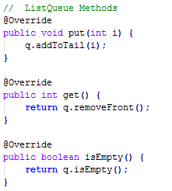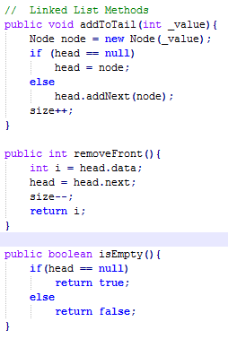

|  |  |
| --- | --- |
| **State** | **Code** |
|  |  |  | H T |  |  | |  |  |  |  |  | |  |  |
|  |  |  |  |  |  | |  |  |  |  |  | |  |  |
|  |  | A |  |  |  | |  |  |  |  |  | |  |  |
| **A** | ListQueue q = new ListQueue() |  | isEmpty() | | | True | | |  | | |  | | |
|  |  |  |  | | |  | | |  | | |  | | |
|  |  |  | H |  |  | |  | T |  |  |  | |  |  |
|  | Put(22) |  | 22 |  | 67 | |  | 79 |  |  |  | |  |  |
|  | Put(67) | **B** | Ref | 🡺 | Ref | | 🡺 | null |  |  |  | |  |  |
| **B** | Put(79) |  | isEmpty() | | | False | | |  | | |  | | |
|  |  |  |  | | |  | | |  | | |  | | |
|  |  |  | H T |  |  | |  |  |  |  |  | |  |  |
|  | Put(41) |  |  |  |  | |  |  |  |  |  | |  |  |
|  | Get() | C |  |  |  | |  |  |  |  |  | |  |  |
| **C** | Get() |  | isEmpty() | | |  | | |  | | |  | | |
|  |  |  |  | | |  | | |  | | |  | | |

|  |  |  |  |  |  |  |  |  |  |  |  |  |  |  |
| --- | --- | --- | --- | --- | --- | --- | --- | --- | --- | --- | --- | --- | --- | --- |
|  |  |  | H T |  |  | |  |  |  |  |  | |  |  |
|  | Put(18) |  |  |  |  | |  |  |  |  |  | |  |  |
|  | Put(66) | D |  |  |  | |  |  |  |  |  | |  |  |
| **D** | Put(50) |  | isEmpty() | | |  | | |  | | |  | | |
|  |  |  |  | | |  | | |  | | |  | | |
|  |  |  | H T |  |  | |  |  |  |  |  | |  |  |
|  | Get() |  |  |  |  | |  |  |  |  |  | |  |  |
|  | Get() | E |  |  |  | |  |  |  |  |  | |  |  |
| **E** | Get() |  | isEmpty() | | |  | | |  | | |  | | |
|  |  |  |  | | |  | | |  | | |  | | |
|  |  |  | H T |  |  | |  |  |  |  |  | |  |  |
|  | Put(2) |  |  |  |  | |  |  |  |  |  | |  |  |
|  | Get() | F |  |  |  | |  |  |  |  |  | |  |  |
| **F** | Put(98) |  | isEmpty() | | |  | | |  | | |  | | |
|  |  |  |  | | |  | | |  | | |  | | |
|  |  |  | H T |  |  | |  |  |  |  |  | |  |  |
|  | Get() |  |  |  |  | |  |  |  |  |  | |  |  |
|  | Get() | G |  |  |  | |  |  |  |  |  | |  |  |
| **G** | Get() |  | isEmpty() | | |  | | |  | | |  | | |
|  |  |  |  | | |  | | |  | | |  | | |
|  |  |  | H T |  |  | |  |  |  |  |  | |  |  |
|  | Put(2) |  |  |  |  | |  |  |  |  |  | |  |  |
|  | Put(41) | H |  |  |  | |  |  |  |  |  | |  |  |
| **H** | Put(27) |  | isEmpty() | | |  | | |  | | |  | | |
|  |  |  |  | | |  | | |  | | |  | | |
|  |  |  | H T |  |  | |  |  |  |  |  | |  |  |
|  | Put(30) |  |  |  |  | |  |  |  |  |  | |  |  |
|  | Get() | I |  |  |  | |  |  |  |  |  | |  |  |
| **I** | Put(17) |  | isEmpty() | | |  | | |  | | |  | | |
|  |  |  |  | | |  | | |  | | |  | | |
|  |  |  | H T |  |  | |  |  |  |  |  | |  |  |
|  | Put(85) |  |  |  |  | |  |  |  |  |  | |  |  |
|  | Get() | J |  |  |  | |  |  |  |  |  | |  |  |
| **J** | Final State |  | isEmpty() | | |  | | |  | | |  | | |